

Web News

Web News
304 Greenway Ave.
Enterprise America, NY 13220
Are you a news enthusiast?
Subscribe today to the most read on-line news in the city.
Top Stories of Enterprise America
Dance Contest
Today’s Weather
Mayor’s Announcements
And Much More!

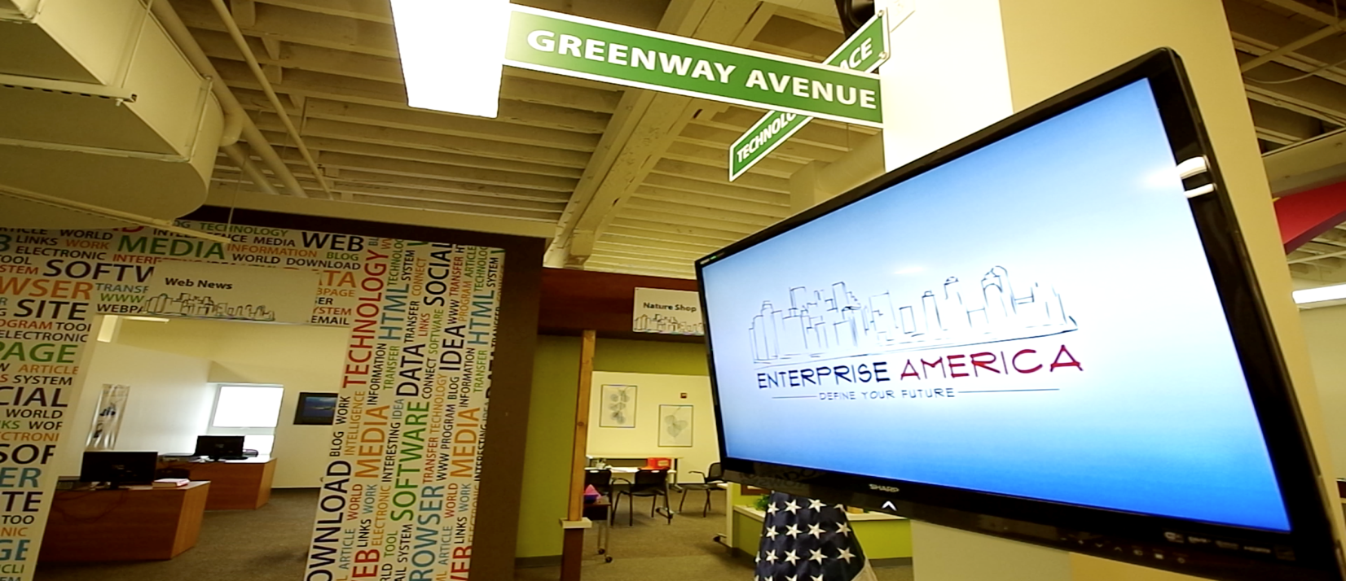
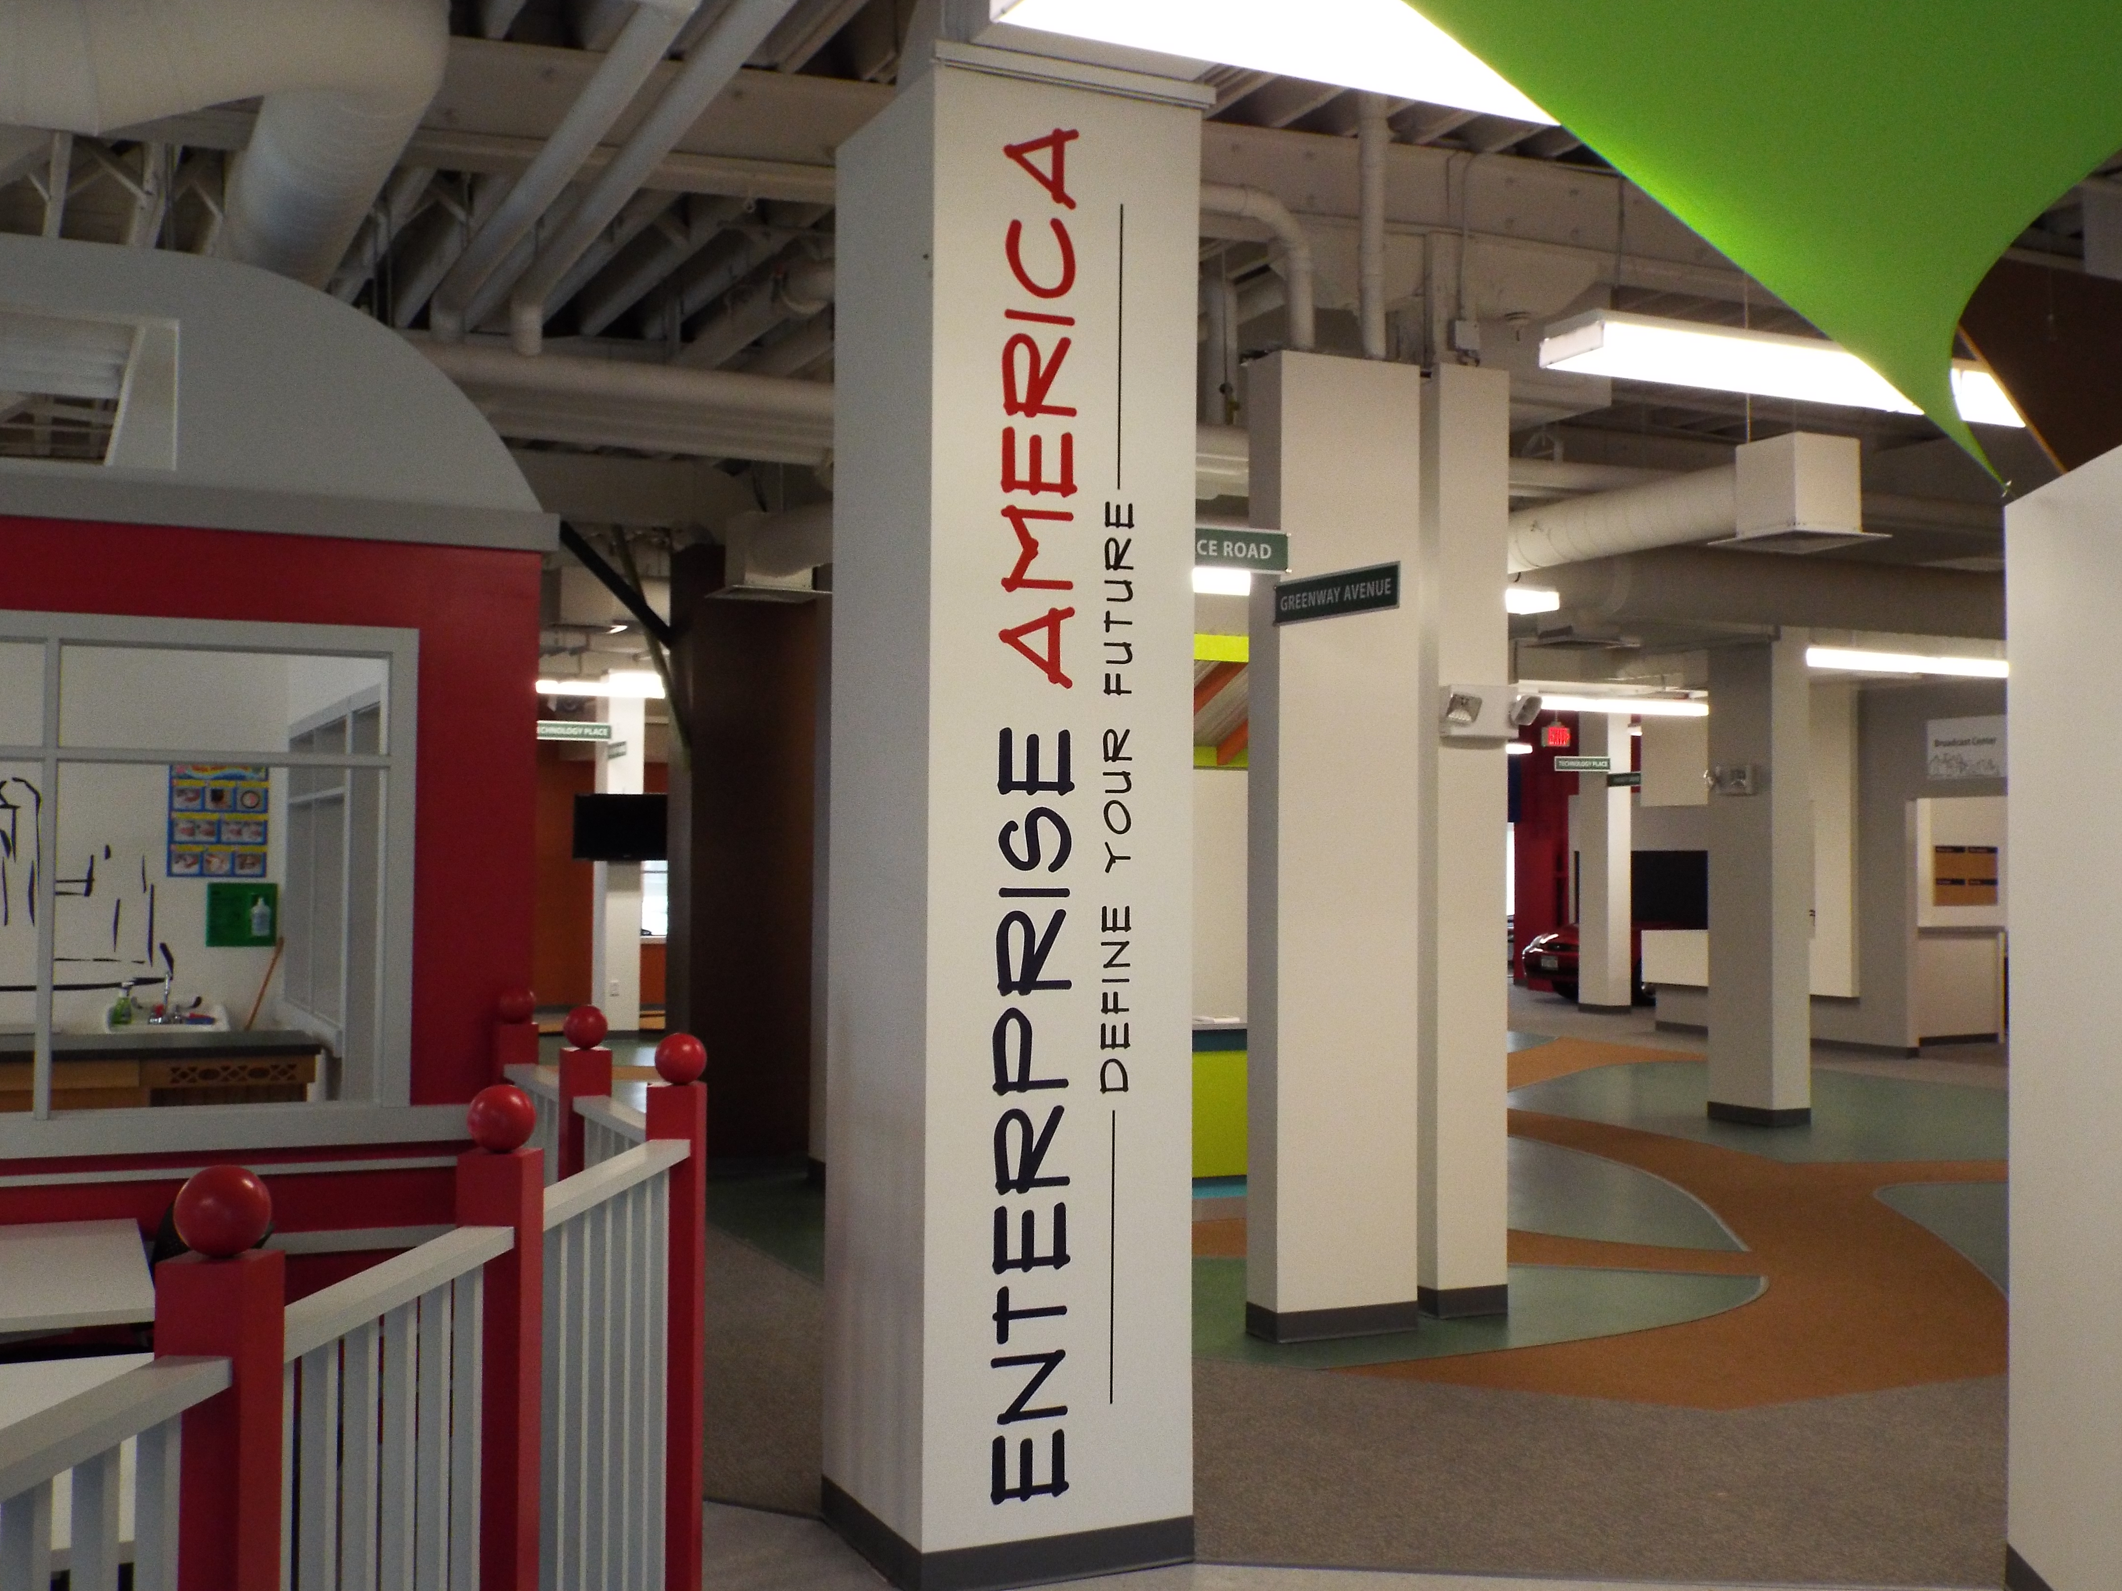

Advertisements 2

Sign Shop

Reese’s Sign Shop sells signs, bookmarks, business cards, and more! Everything is cheaply priced but has a good quality! There are six people working although all has different jobs. Find us Monday-Friday at Technology Place Syracuse, NY 13220, from 7AM-9PM. Call (1800)-Reeses Sign Shop to get the best signs out there!

National Grid Utility Company

Come on down to the Sunflower Co. the best utility company in to get your electricity.

Web News

All day, every day, Enterprise News will feed you your information of the drama round town. With family friendly news reports and informational images we will leave you informed. Join us, Enterprise News and let us be a part of your lives. “Enterprise News, Your Local News All Day, Every Day”

Nature Shop

We sell bracelets, hair clips, sand art bottles, and bracelets. We help you get in contact with nature itself. With our cheap prices you are sure to get a great deal.

Wellness Center
  - Have you ever wanted or had to go to the doctor but didn’t want to pay the outrageous prices? Well now you’re in luck! Come on down to the Enterprise Health Center for cheap and affordable health care. The Enterprise Health Center helps throw your pain and stress away for cheap and affordable prices.
CORRUPT CAFÉ
As mentioned on the previous page, the café prices are way more than they should be. I spoke to some of the employees, which agreed with this. One employee, who wishes to remain anonymous, said that the popcorn costs $25 to make, so $5 is a good price. However, when speaking to the manager, Colin Ringwood, he said he thought the prices are fair. Ringwood seems to be the cause of these prices. More tomorrow.

CORRUPT CAFÉ
Earlier today while on break, I went down to the café to get some popcorn. I was utterly outraged when I saw the prices. $5 for popcorn, $3 for granola bars and trail mix, but the worse was the water. The water, one of the very things we need to live, costs $3. The popcorn costs $5, and since it’s salted, your mouth would become dry, making you want water. Right there is $8 they’re ripping you off.
Continued on page 3.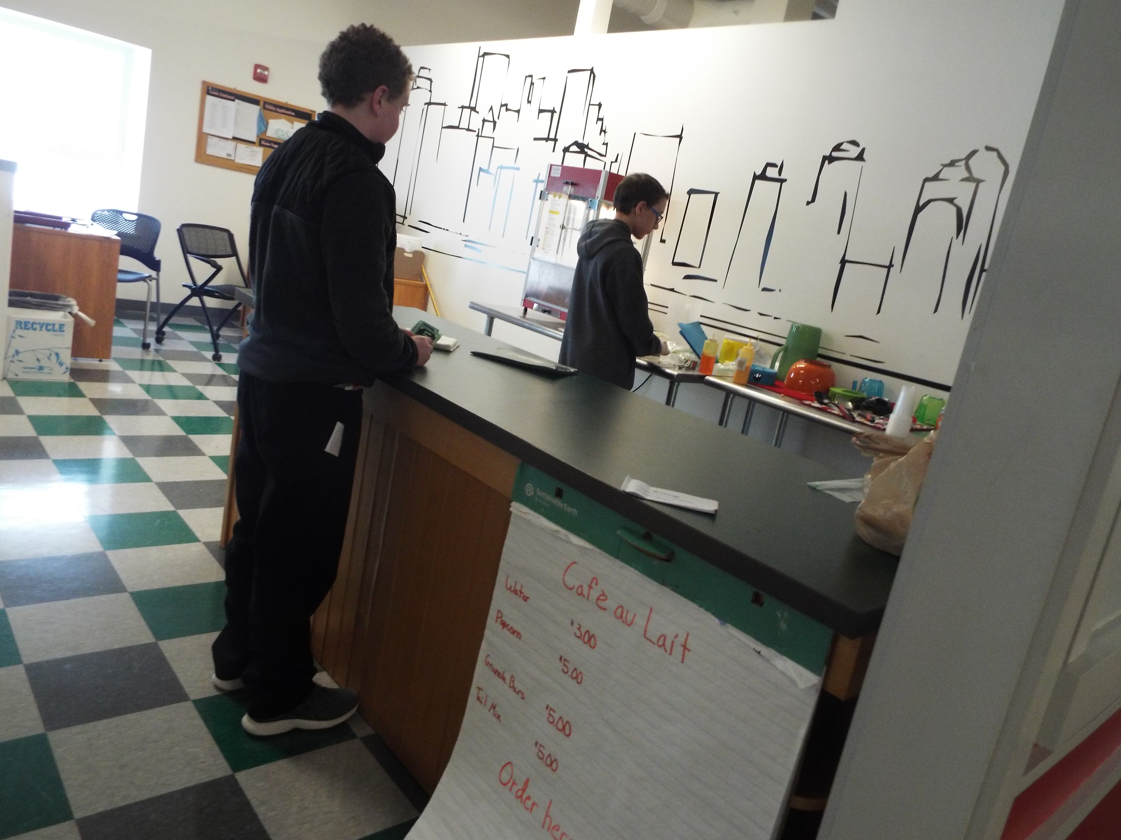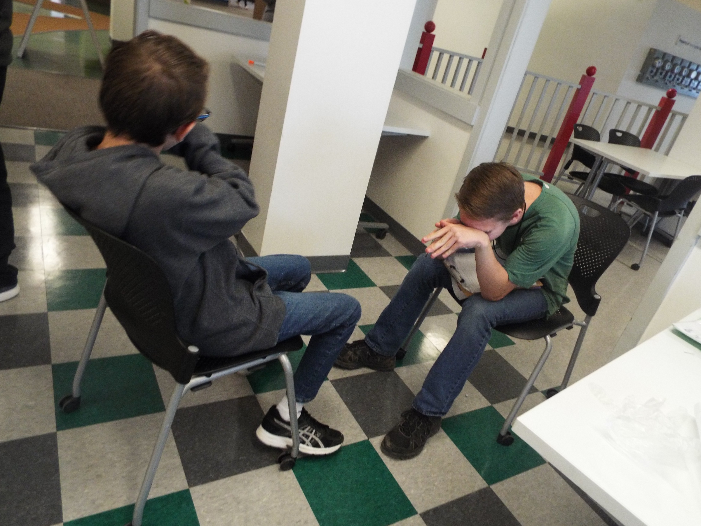

Headlines

Staff
-Jacob Nickerson
(Managing Editor)
-Maggie Hutchins
(Sales Executive)
-Madison Pulsipher
(Accountant)
-Iara Ramirez
(Reporter; Photo Journalist)
Connor Barrigar
(Senior Reporter; Co-Editor)

Advertisements

Broadcast Center
  - Is there a song that’s been stuck in your head? Well come down to Enterprise-America Broadcasting Center. We have all the best music.
Café
  - Café Dulait will provide you with popcorn, kool-aid, granola bars, and trail mix. We also have a perfect place to go when you’re on your break. The popcorn is made fresh minutes before you get here.

Pathfinder Bank
  - The Money Moves Bank will help you with opening checking accounts, deposit money, and pay off loans.
  - -Mason Jones(President), Amelia Mack(Vice President), Mia D’Angelo

Delivery Center
  - “Get It In A Minute” When our company runs out we’ll get you your materials. We are unrepeatable, no hassle, get to you in a minute. Not hours.

City Hall
  - www.enterprisecityhall.com
Our #1 priority is protecting our citizens of Enterprise America. We are fair and respectful. We offer grass passes and liscenses. Give us a call, City Hall!

