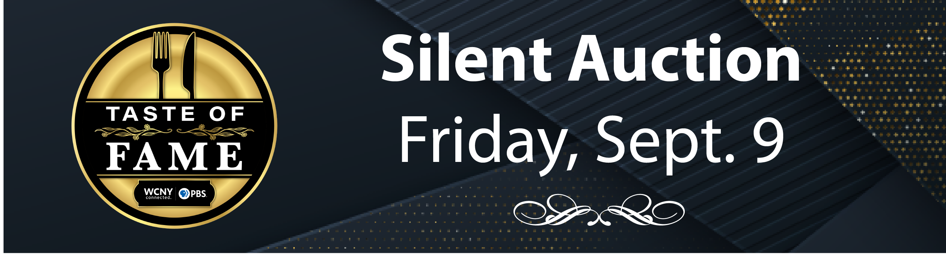
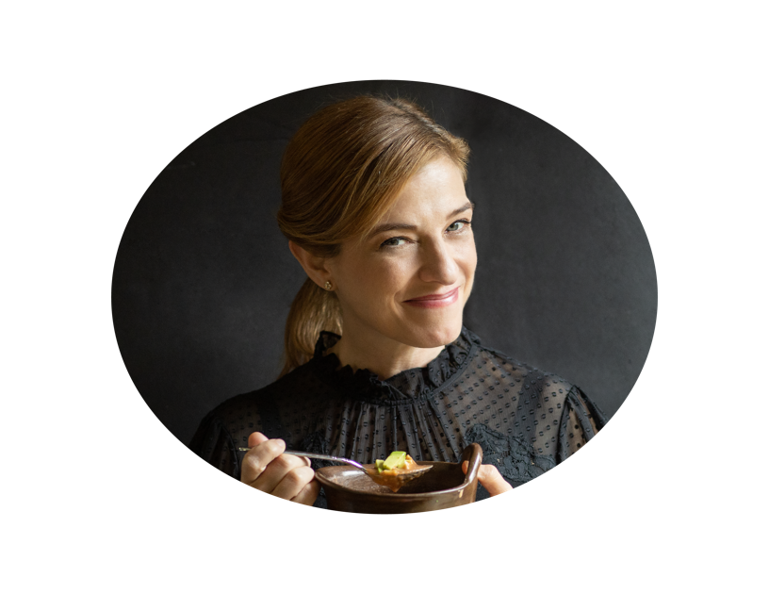

TASTE OF FAME WITH CHEF PATI JINICH
AT DRUMLINS COUNTRY CLUB, SYRACUSE
WCNY’s 8th annual Taste of Fame signature fundraising culinary dinner experience returns to CNY! Join Award-Winning Celebrity Chef, Author, and Host of “Pati’s Mexican Table,” Chef Pati Jinich at Drumlins Country Club! Enjoy a three-course culinary dinner journey with recipes inspired by Pati’s new cookbook, “Treasures of the Mexican Table”, and stories to accompany each course. The best in Finger Lakes wine, cocktail hour, and a silent auction is included.
VIP ticket holders are invited to attend an exclusive meet and greet event at 4 p.m., prior to the three-course dinner. The VIP event features a meet and greet, and photo op with Pati, exclusive screening, and an autographed copy of Chef Pati’s “Treasures of the Mexican Table.” Chef Julia Collin Davison from America’s Test Kitchen will emcee the VIP event and the three-course dinner.

IF INTERESTED IN BEING A PART OF OUR SILENT AUCTION BY DONATING AN ITEM(S), GIFT BASKET, OR CERTIFICATE, YOUR COMPANY WOULD RECEIVE ONE OF THE FOLLOWING LEVELS IN RETURN FOR YOUR TOTAL DONATION $ VALUE:
THANK YOU!
We appreciate your consideration. All donors will receive a tax deductible thank you letter at year-end.

Donation Deadline
To donate or learn more, please contact Sara Strong at sara.strong@wcny.org or call (315) 453-2424

The deadline to donate is Friday, Sept 2. We are happy to receive drop-offs or pick up donated items.

ITEMS $50-$99
- Name, logo, link on wcny.org/tasteoffame website
- Included in event program
ITEMS $100-$249
- Above benefits PLUS
- Company logo included in event signage
- Company logo included in email promotion

ITEMS $250-$499
- Above benefits PLUS
- 1 – e-guide ad (email delivered electronically to 32,000 subscribers)
- Company logo included on wcny.org Taste of Fame web banner
- Thank You recognition in Nov/Dec Connect Magazine

ITEMS $500+
- Above benefits PLUS
- Tag on WCNY’s Facebook page (20.000+ followers)


