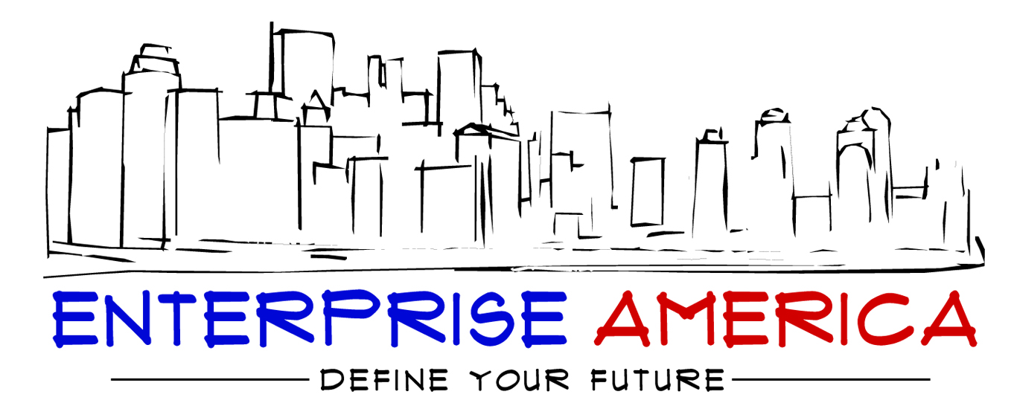

Web News

Web News
304 Greenway Ave.
Enterprise America, NY 13220
Are you a news enthusiast?
Subscribe today to the most read on-line news in the city.
Top Stories of Enterprise America
Dance Contest
Today’s Weather
Mayor’s Announcements
And Much More!

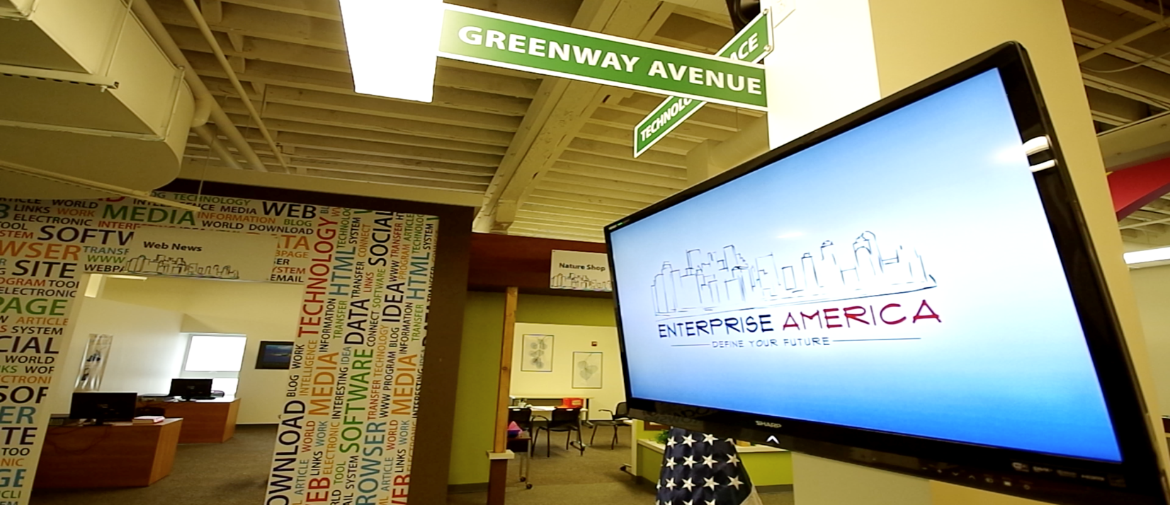
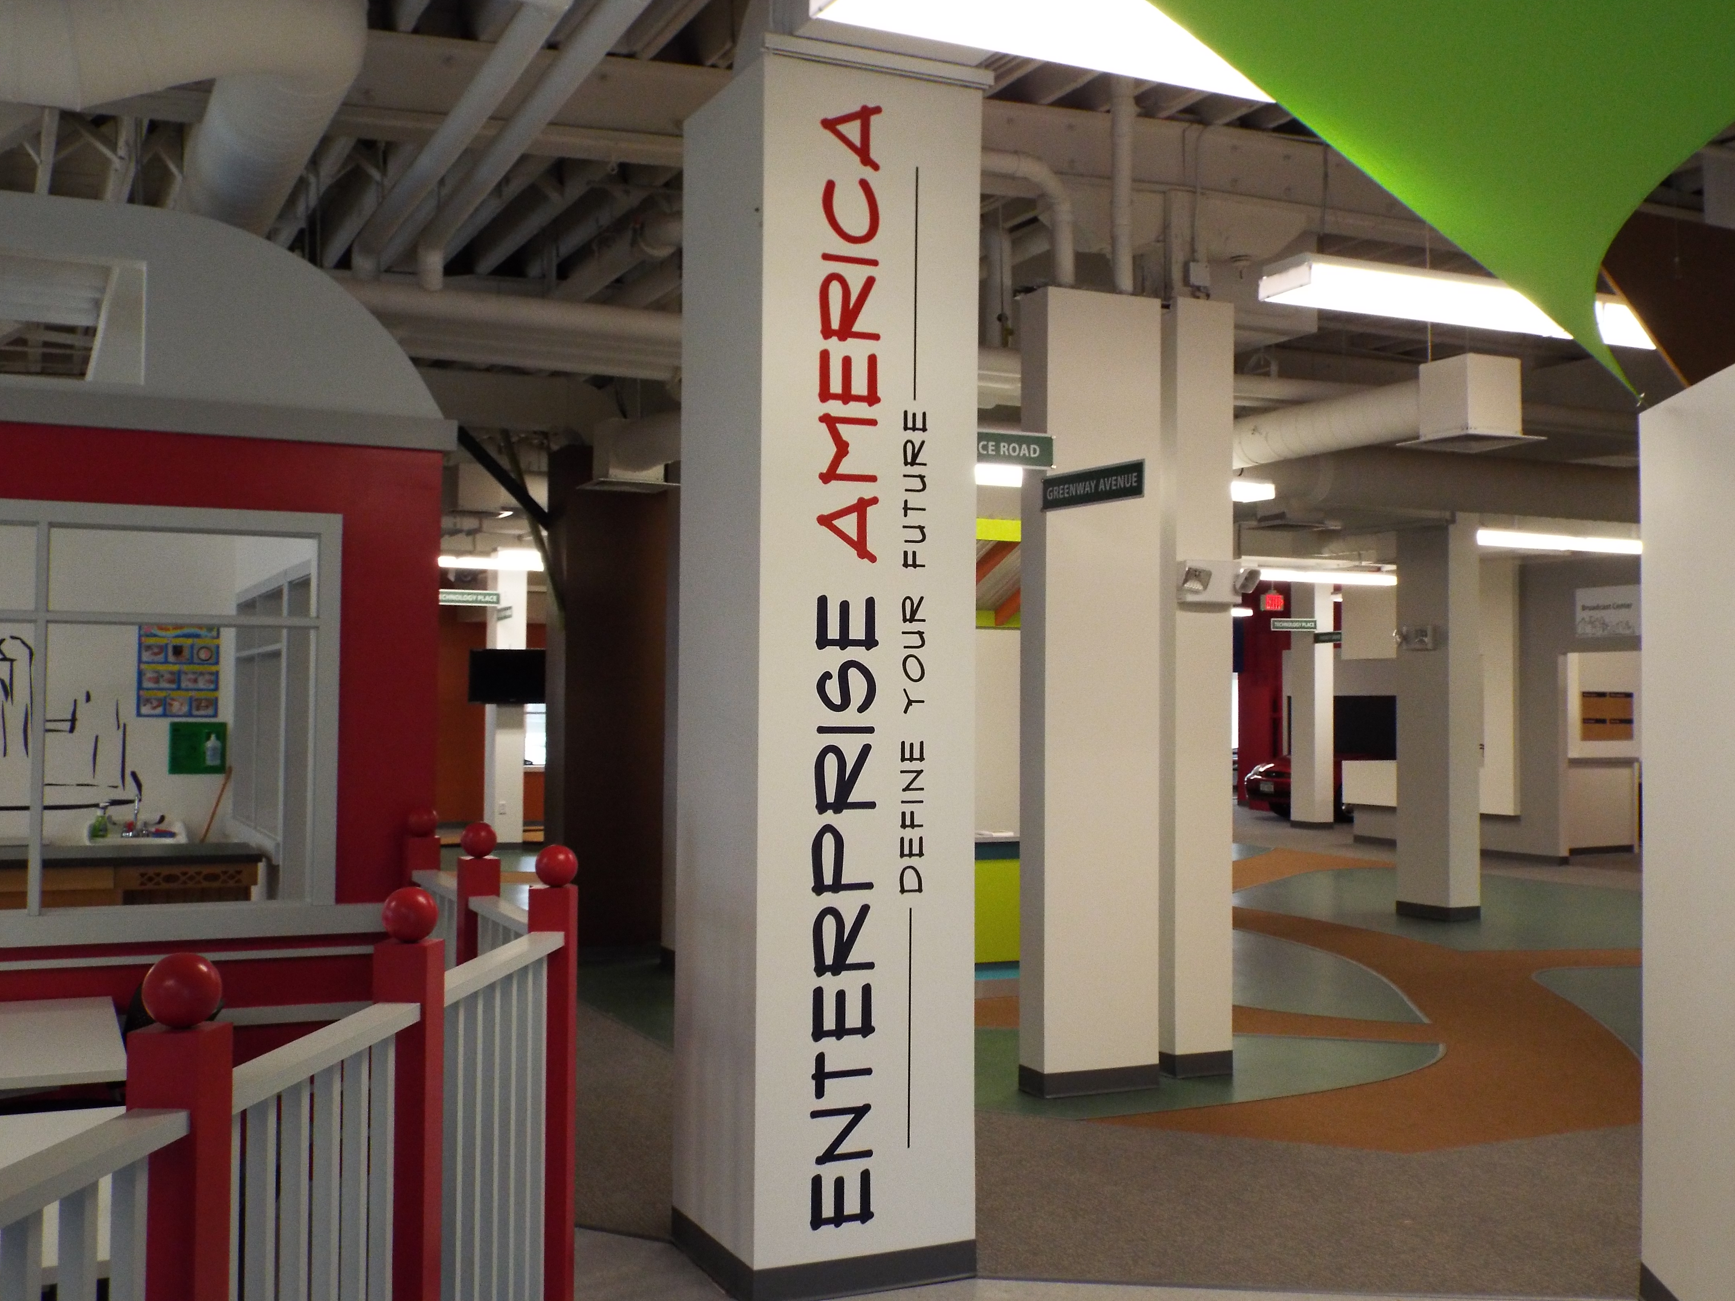

Headlines

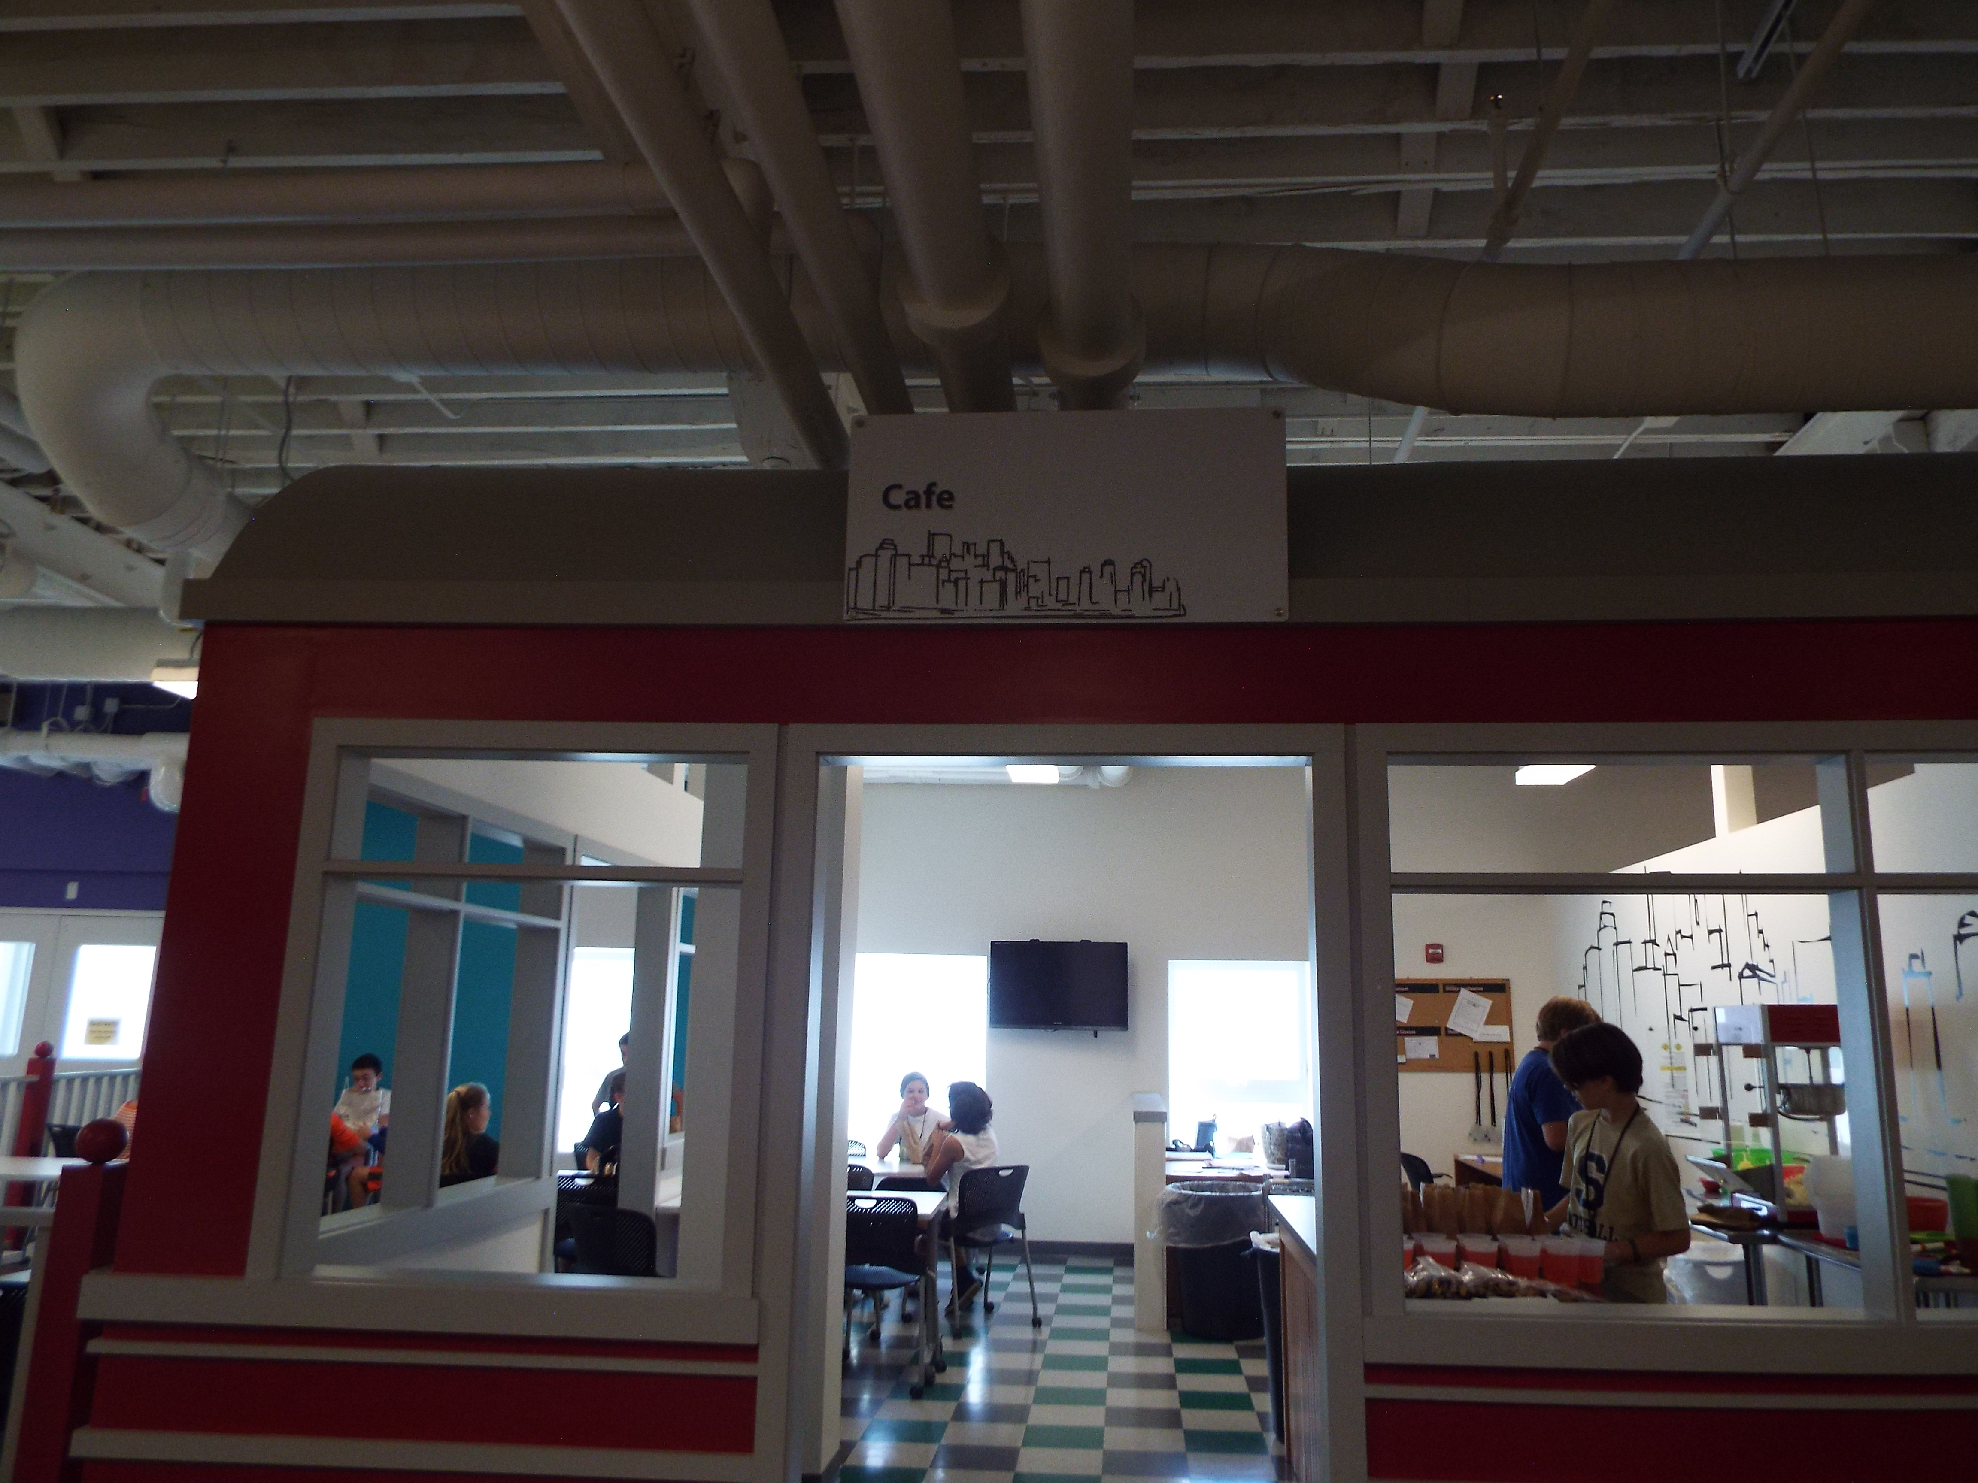

WHAT IS THE DELIVERY CENTER?
Some people have been wondering what the Delivery Center’s role is in the Enterprise America city, so our reporters interviewed Jewel, the owner. Jewel told us that the Delivery Center’s role is to help deliver mail. They also supply products for every business in the Enterprise America . The Delivery Center is crucial in keeping every business in Enterprise America supplied with their products. Also, if you have mail, the Delivery Center will bring it to you. Stop by the Delivery Center today to see what they are all about!

The Sport Shop is so happy that it has figured out how to make their products . In fact, they were jumping for joy and singing. Please stop by the Sport Shop to check it out and play pop a shot while you are there.
THE CAFÉ HAS A NEW MENU!
The café at Enterprise America has an all new menu. On your lunch break, stop by the café to enjoy lemonade, pizza, water, Kool-Aid, granola bars, trail mix, or popcorn. Come visit the café today to have a tasty snack!

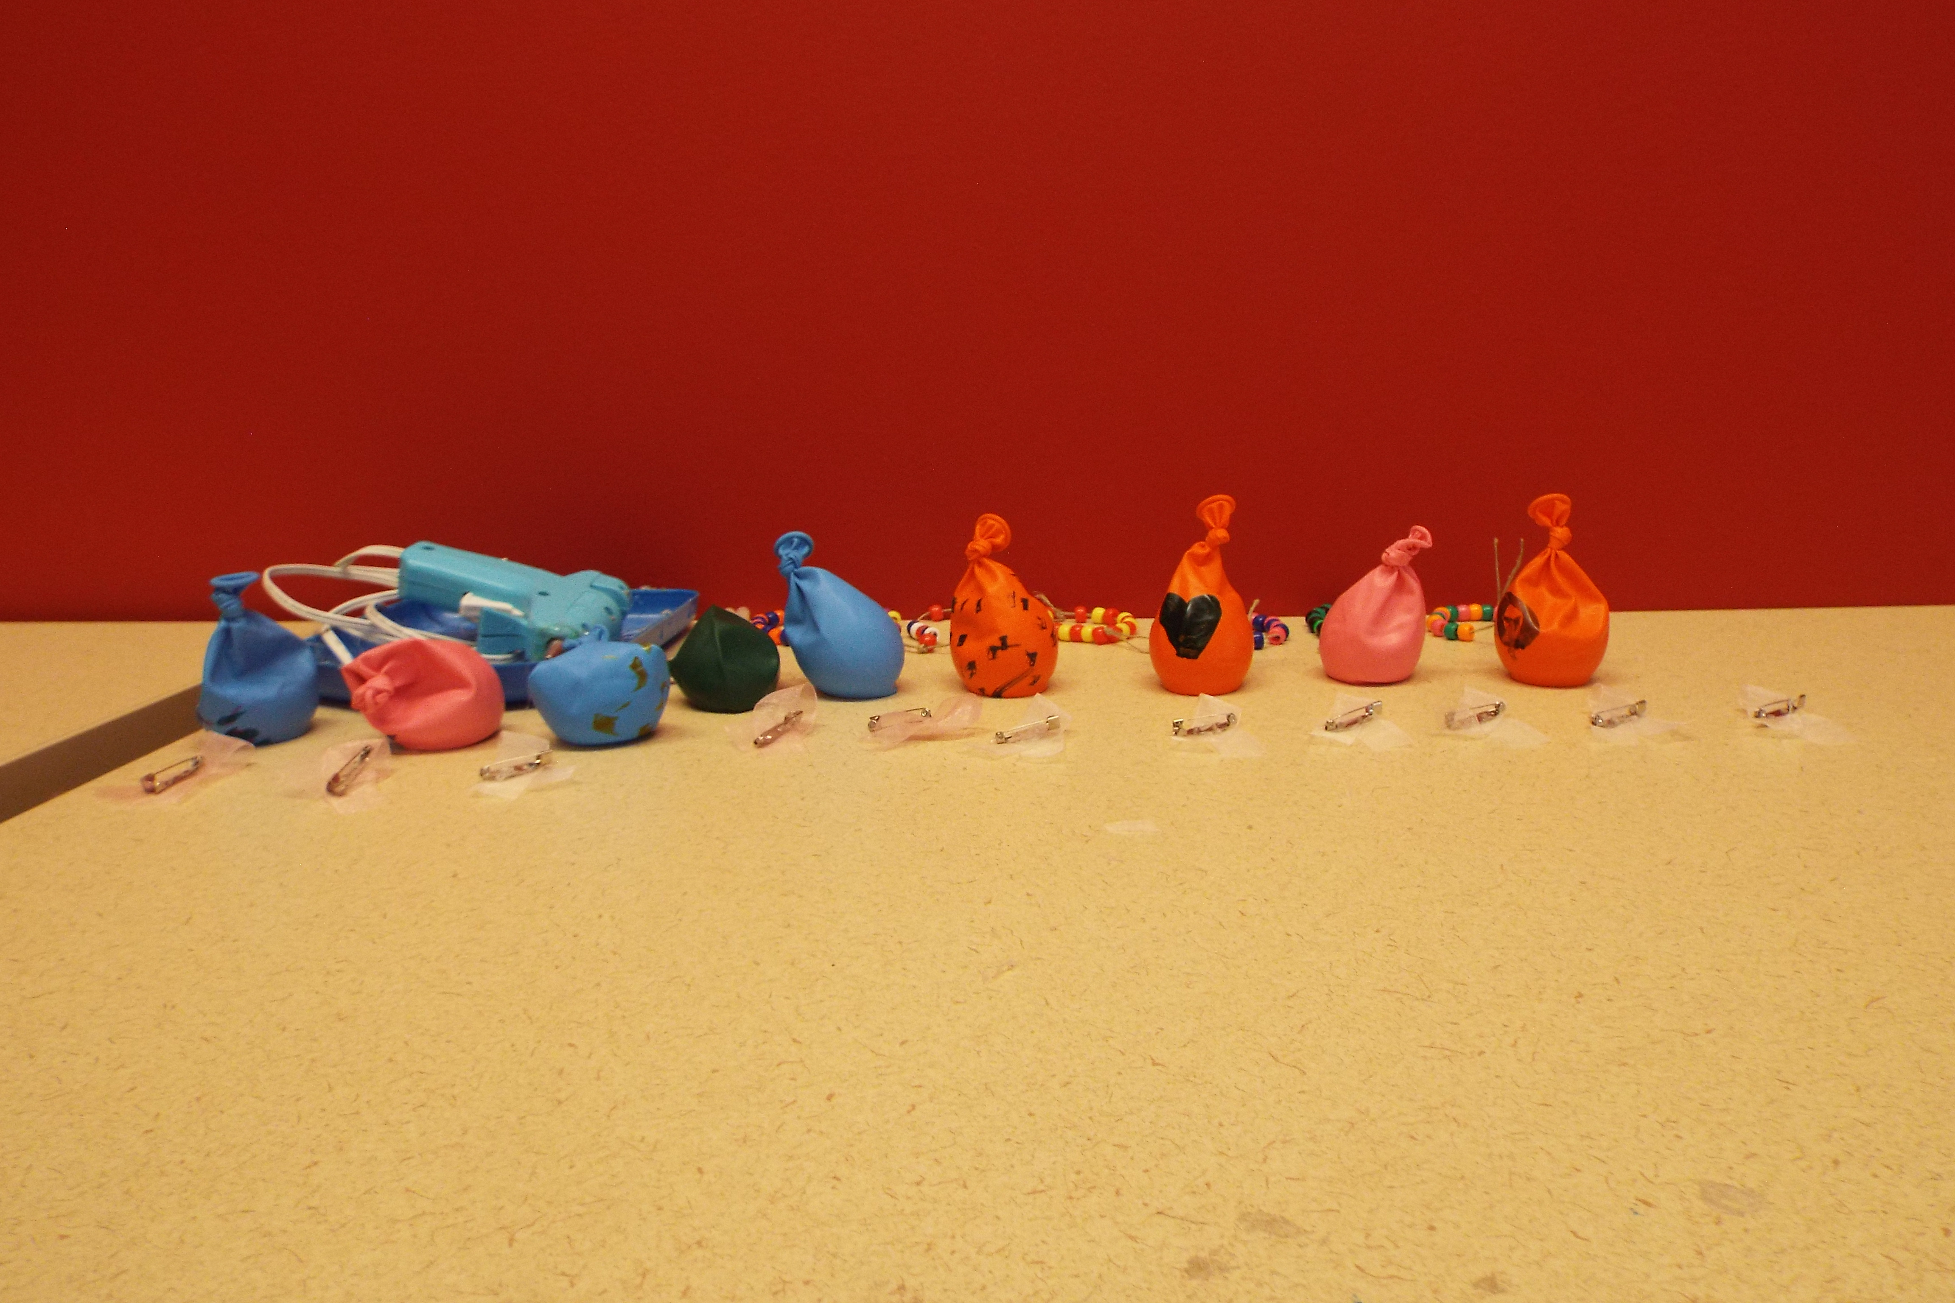
Picture
Picture
MANUFACTURING CENTER
The manufacturing center is selling all kinds of different pencils. They have furry pencils, flower pens, tic-tac boards for all cheap prices! Manufacturing Center makes sure everyone has writing supplies and no one is having trouble having to find something to write with! They also sell tic-tac boards and make sure everyone is buying something fun and will have a good time.

Picture

Picture

Stories

Advertisements

Broadcast Center
Enter the broadcast Center because we’ve got the news, we’ve got the moves, and we’ve got the views. We will help your business advertise to let more people know your business. We also give shout-outs and take music requests. We will hold dance competitions too at a reasonable price. Listen in citizens, because we have frequent news stories. Come down here to the Broadcast Center Today!
Café
The café is an amazing place to eat and socialize with friends! Take a break and enjoy popcorn, granola bars, trail mix and a variety of drinks. Also we are open throughout the whole day. The EA café is the place to stay and enjoy your day! We hope to see you soon.

Pathfinder Bank
Are you looking for a place to start your path into greatness, then come to pathfinder bank! We can help you create a bank account. You can also come here to take out loans! Your account holds all of your money, so it is available whenever. So come and find your path at Pathfinder bank!

Delivery Center
Need supplies? Call the delivery center for speedy-fast delivery. We deliver your needs for your business to be successful. We also provide start up packs to start your business, we also give you extra materials if you need them.

City Hall
Do you need a license, take care of fines, or pay your business Taxes come to city hall and We can help you with all of these services. We are here to create a comfortable place to live, where everybody is treated equally. “here in city hall we enforce the law”-+

Advertisements 2

Sign Shop
At the sign shop we make custom signs that are designed to perfection for your business. Each sign is only $15 .
That is really a good deal. We also make bookmarks, business cards. Cards and door hangers for any occasion you may have. Our prices range from $3 to $15 . We make signs and design them.

National Grid Utility Company
Come on down to Telsa Shock Utility Company and get shocking low prices on electricity. We have your daily weather forecast. Rent a space for your business with us. You will start dancing with these electrifying low prices. Telsa shock has many services including the most important and most anticipated broadcast of the day, the weather . Don’t get shocked when you see our prices and services.

Web News
Attention everybody it’s the news dudes here with the Webnews. Our mission here at Webnews is to spread the word about what’s going on in your life. Come buy an ad at Webnews and ensure everyone hears your story. A personal ad or picture is $12.60 . A business ad is $10 . Hurry up and buy them now. Space is limited . The news dudes want to share your story. Call us at 1 800 webnews.

Nature Shop
Hop on over to the Nature Shop. We sell pet rocks, hair clips, plastic jewels, colored sand, string by the yard, plastic sand bottles and top , nature beeds, shells and many other items. If you are interested in purchasing any of these items please visit us at 402 Greenway Avenue.

Wellness Center
The Wellness Center is a humble business that makes products for the hurt or distressed. Come down and see us for a non-threatening environment to cool down and relax with our cheap prices. It’s great time to unwind. Come get down with the Wellness Swellnes.

Advertisements
MACNY/PEB Manufacturing Center
You need to write, we’ve got you alright! Come on down to the manufacturing center where we have everything for you.

Non-Profit Organization
Help these very sick kids, make their dreams come true by donating to the non profit organization, all of your proceeds go to the make a wish foundation and in return, you receive a blue make a wish star that is a gift to show that you have donated to us. The star in the kids are provided by the stars in you.

Technology Center
We are the technology shop we can provide you with tech services. If you want to advertise something, we can do that for you! We offer personnel ads and personnel promotions. Promote your business quickly with our services. Your business will boom with our ads. We provide personal promotions such as social media pages. We are the technology shop and we put the ad in advertisement!
Automotive Shop
Come on down, we will fix your car, so you can drive around. We have key chains, air fresheners and more. These products have an affect on the community by making your car smell brand new. Also by making old backpacks

Sports Shop
Have you ever thrown a party, and didn’t have any games to play? Well come on down to Tylers RRR Sport shop. We have bean bag toss games to entertain your guests. Need party favors? You can get sport badges to send your guests home with. Come down to 204 Energy Dr. your shots will always drop, at the sports shop.

What business has the best customer service and why?
The Sport Shop has been the best customer because it has paid its bill on time and makes it fun to play pop a shot.
I think it is a fun learning experience!
- Margaret Mello
Picture
What does the Non-Profit Organization benefit today?
The non profit organization benefits the make a wish foundation today.
Enterprise America is a great place for students to learn what it is like to run a business. We got paychecks and got to spend our money on real products throughout the day. You should make sure to tell your friends how great the Enterprise America Program is.

When you go to Enterprise America you get to listen to music and to participate in a dance contest. It is so fun! I wish that we could go to Enterprise America every day.

Editorials
I like how we can buy real products!
- Taryn Mann

Thank You
Courtney Chapman made a donation to Web News!
Anna Linsky made a donation to Web News!
Elianna Cui made a donation to Web News!
Logan Battaglia made a donation to Web News!

Thank You

